In the name of flower, blossoming in romance
Inspired by the life circle of flower, witness the blossoming moment of female. By using an avant-garde fashion design, to compliment the power of life, and create a modern beauty. STACCATO cooperates with the most sought-after “talented designer” Robert Wun, launch the crossover collection #Armor Flowers#. This collection uses “lily flower”as design concept, which is the most iconic concept of designer, outlines a sharp silhouette and the structure of a vivid life, conveys a beautiful expectation to the nature and reality. In the name of flower, blossoming in romance

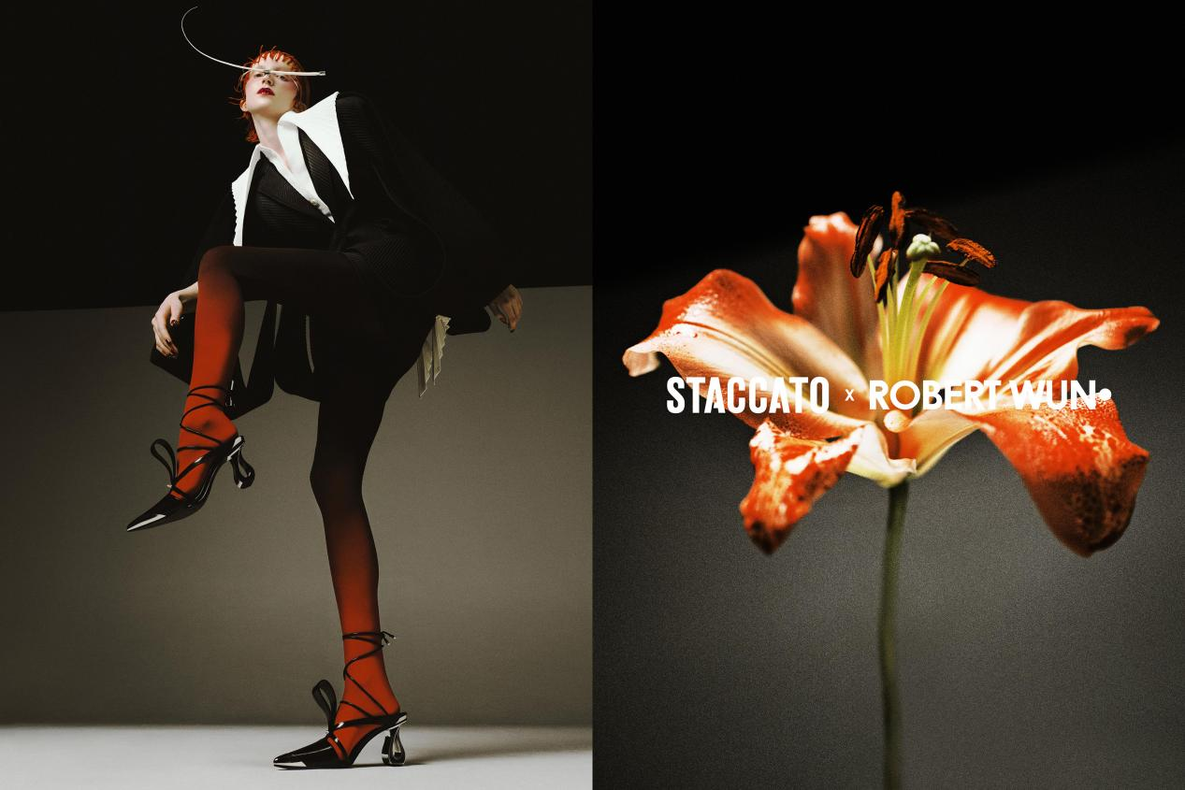

ARMOR FLOWER SHOES
Inspired by lilies blossoming, The openwork 3D petals fit snuggly on the upper, the irregular cut completes a 3D sculptural beauty outlook.The branches around the ankle present a liberal and flexible touch to highlight a slender appearance. The futuristic metallic pointy-toe and irregular metal heel offer special cool feeling which is masculine yet feminine.

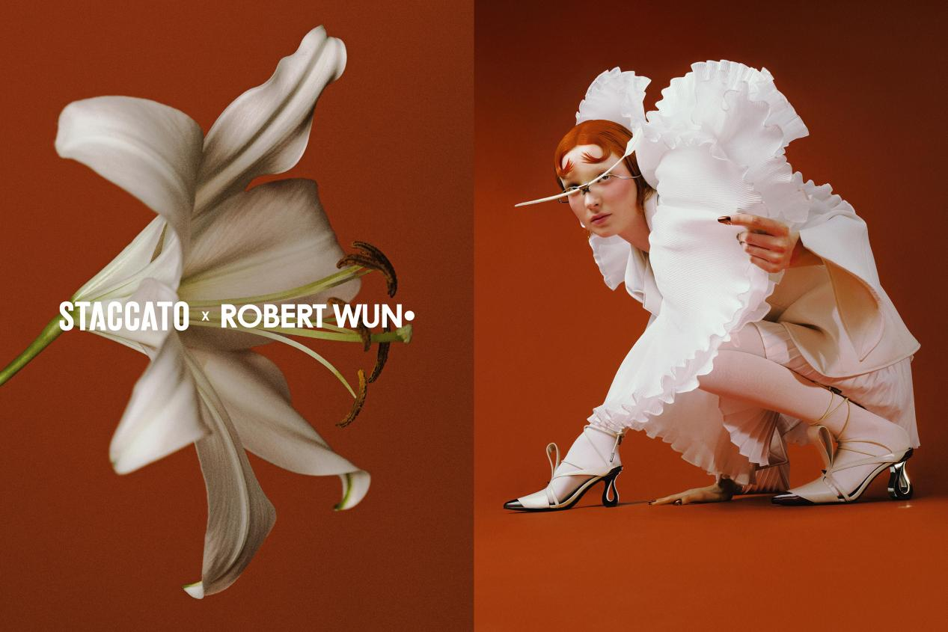
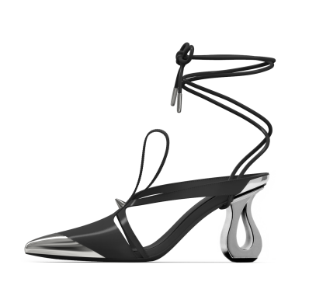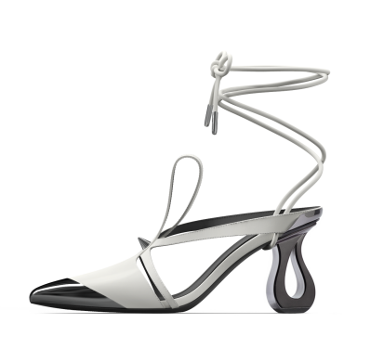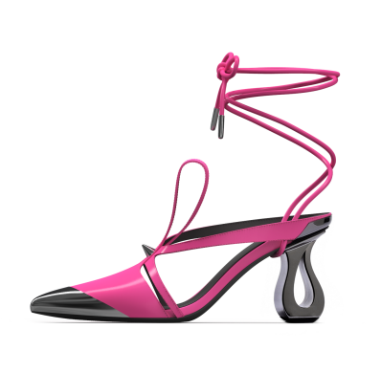

The bud-shaped design shows the natural charm of life circle. The irregular openwork design highlights an ultimate brilliant and healing touch adds a lightweight and breathable touch.Super simple black and white color tone and metallic heel, create contrasting colors with a sassy style to express a joyful mood.
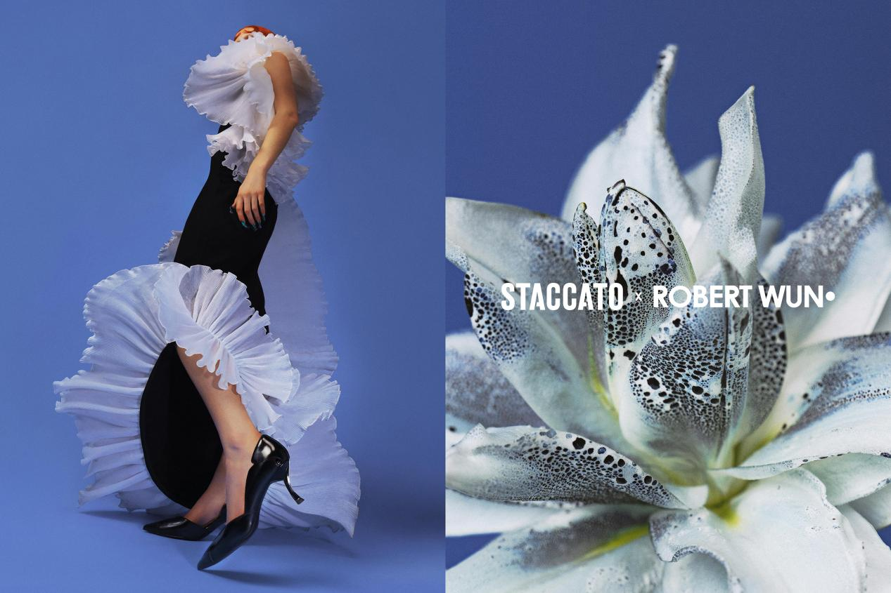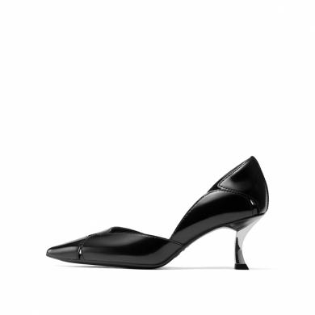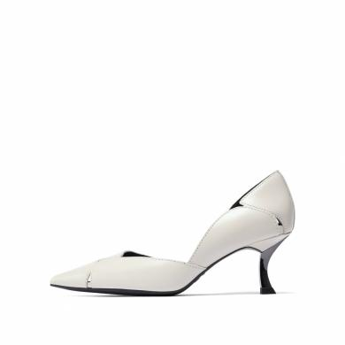

The irregular openwork design create a bud-shaped design, the tonal petal heel offers the ultimate art imagination, explore the brilliant life energy. The neat open-cutting at the back interpret a special fashion sexy, enhance the personality charm.

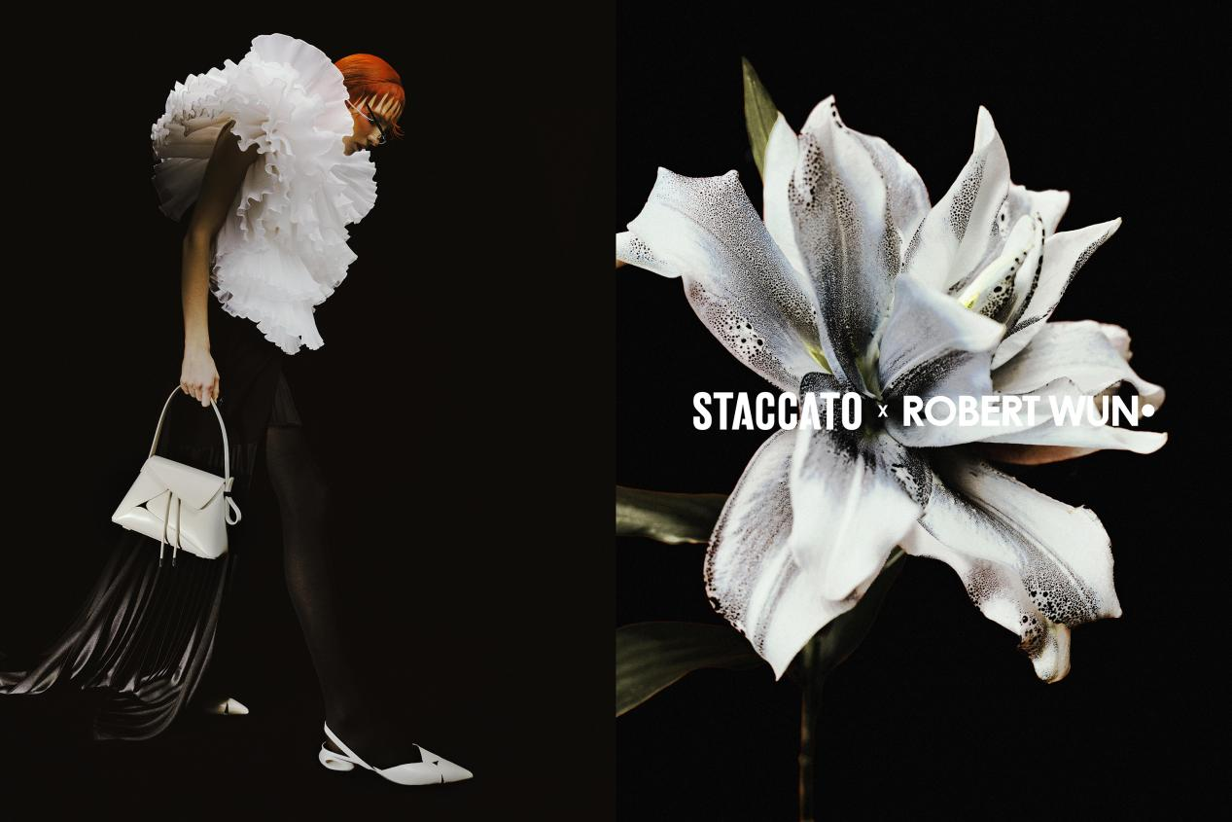
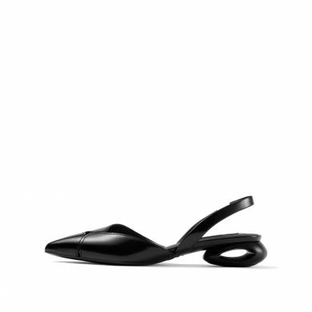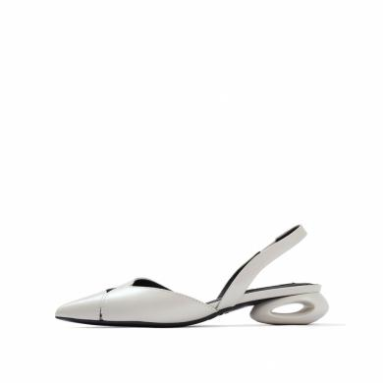

Glossy textured leather highlights an understated yet gorgeous aesthetic.The metallic pointy toe ultimately prolongs the silhouette, interpret the lily blossoming in a cool sense. The neat open-cutting at the back which is offering an ergonomic and comfortable fit, and creates a long leg visual sense. Gemstone shape metallic heel strengthen the art aesthetic, makes it easy to wear elegantly and playful

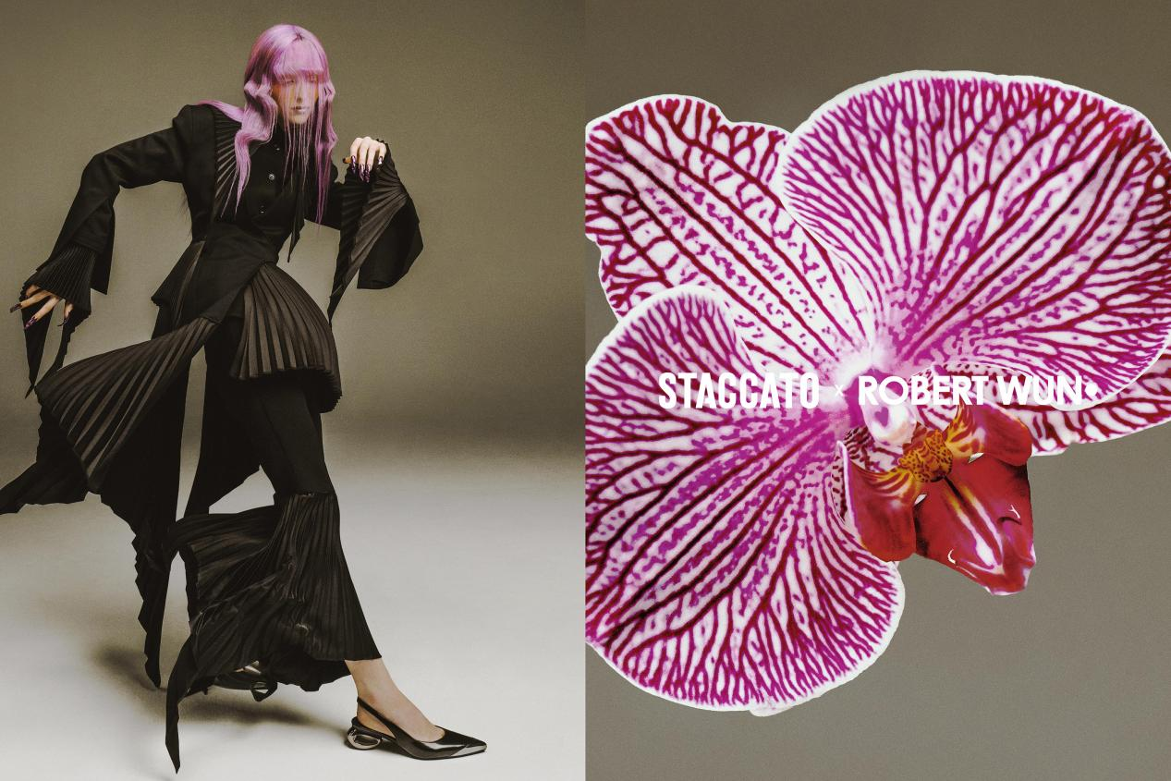
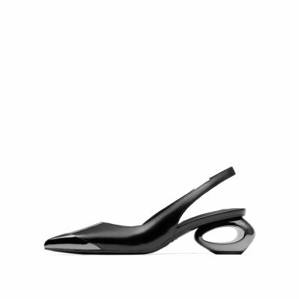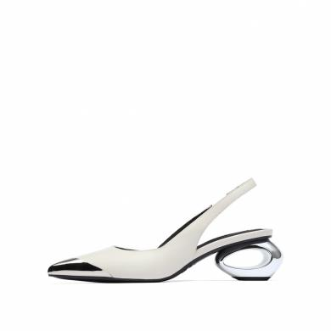

ARMOR FLOWER BAGS
Through the architectural sculpture cutting,the soft textured leather offers a different layers of petals shape. The interior tonal cotton/linen drawstring pocket, embellished with a swaying strap and shoulder strap with a metal buckle, presents a fresh and modern look.

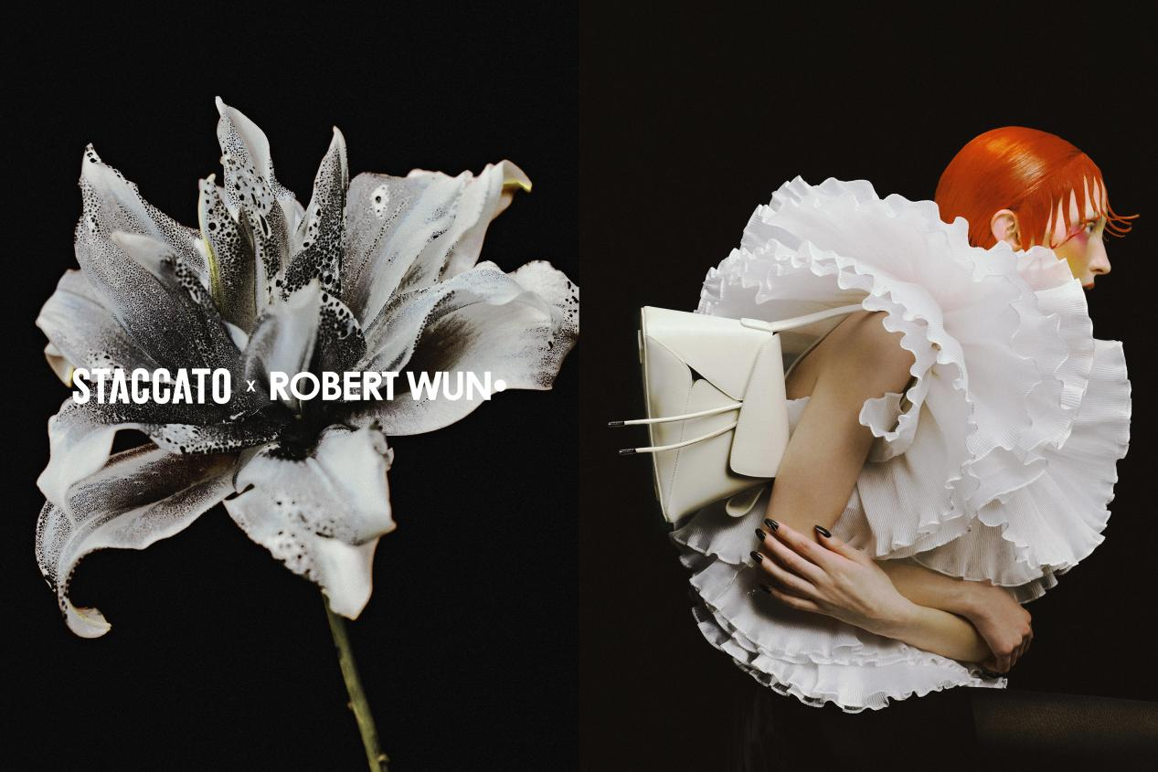
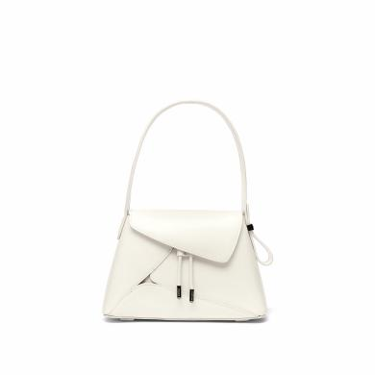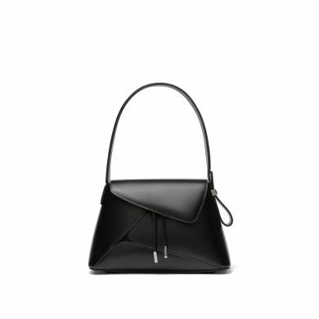

Further more, inspired by the design concept of armor flowers, STACCATO create a series of cool limited edition packing and merchandise.
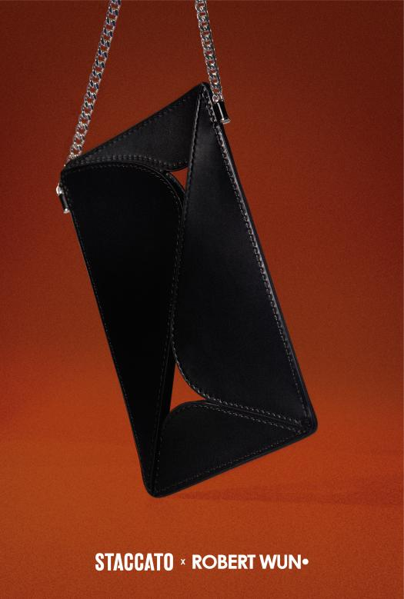

Robert Wun Introduction

Founder and creative director of brand ROBERT WUN. Strongly recommend by VOGUE, most sought-after designer by KOL & celebs. Born in HK, grew up in London, The diverse cultural background has profoundly affected his unique fashion perspective.
He is good at the interaction between sculptural silhouettes and futuristic materials, he injected a unique "new futurism" design language into women's apparels.
In 2022, ROBERT WUN won most important prize in international fashion industry -- ANDAM awards special prize, his stunning avant-garde creativity has made him a hotly debated dark horse in the fashion industry.
In 2023, ROBERT WUN first appeared in Paris haute couture Week,played an important role in the ending show with STACCATO crossover series “armor flowers”.
