 |  | 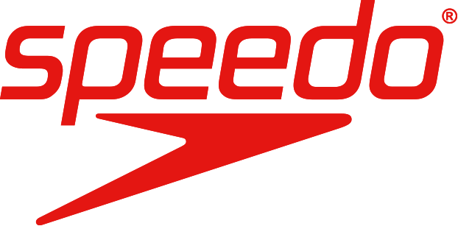

PRESS RELEASE For Immediate Distribution

Maximizing Swimming Experience for All Levels, Speedo Launches Speedo Fastskin LZR Swimsuit with Professional-Athlete Standard

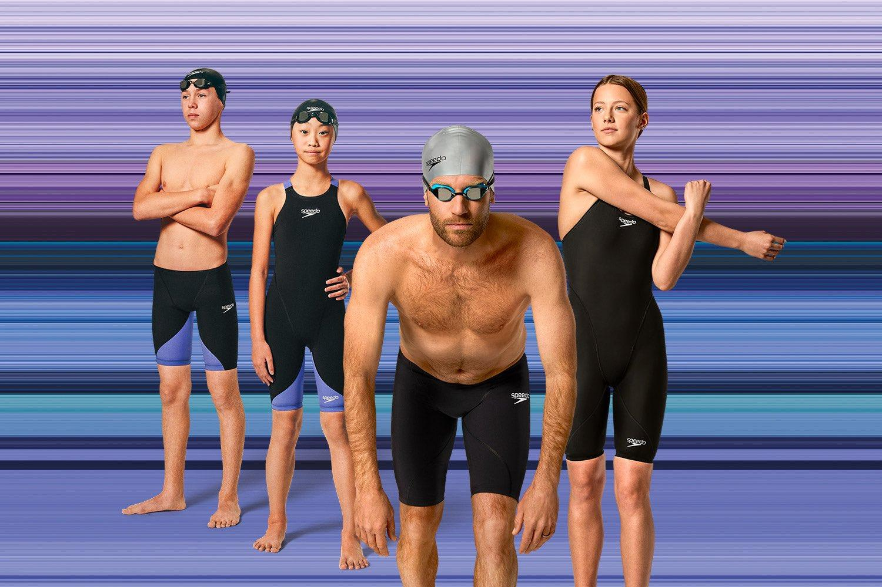

Jakarta, April 14, 2023 – As the world’s leading swimwear brand, Speedo wants to continue to inspire and support all activities in the water on various occasions. This time, Speedo launched the Fastskin LZR Ignite - the newest professional athlete-standard swimwear, which has now become available and sold to the public for the very first time.

"Speedo's mission is to inspire people to swim and we are beyond proud to launch this Fastskin LZR Ignite swimsuit which is inclusive to every swimmer. Previously, the Fastskin swimsuit series was exclusively reserved for athletes, but with the Fastskin LZR Ignite series, all its advantages can be experienced by every swimmer.” said Lilyana Gani, Brand General Manager of PT MAP Active Adiperkasa Tbk.

Speedo Fastskin LZR Ignite is designed for comfort while swimming, even during long meets. Fastskin LZR Ignite has a strap that will not rub harshly against the skin making it comfortable to wear. Made with light yet strong fabric that allows users to explore the world of water flexibly.

With all its advantages, the Speedo Fastskin LZR Ignite will allow all swimmers to experience what it's like to maximize their speed in the water. This swimsuit has been designed for various strokes and distances (all-round suit). Our goal is to help swimmers to achieve their Personal Best, seen as a major progress milestone, to be worth all the dedication and time to practice.

The entire Speedo Fastskin LZR Ignite collection is available offline at selected Planet Sports Asia (Grand Indonesia Jakarta, Pondok Indah Mall Jakarta, Senayan City Jakarta, Galaxy Mall Surabaya, Beachwalk City Bali), Speedo Proshop Siliwangi Bandung, and online at https://www.planetsports.asia/speedo-fastskin-ignite-suit with prices starting from IDR 1,999,000 to IDR 3,499,000

***

ABOUT PT MAP AKTIF ADIPERKASA TBK (MAPA)
PT MAP Aktif Adiperkasa Tbk (MAPA) is a 'brand commerce' entity that manages and markets international brands in Indonesia. A subsidiary of PT Mitra Adiperkasa Tbk (MAPI), MAPA manages more than 40 exclusive brands in 1,263 outlets and 11 online sites. The company's three main business segments are Sports, Leisure Footwear and Kids products, which are sold through a multi-brand, mono-brand outlet format that is directly owned by MAPA, including PlanetSports.Asia, Sports Station, Golf House and Kidz Station. In 2018, the company acquired Astec, a leading badminton, fitness, and leisure activity brand at the regional level, which was founded by Alan Budikusuma and Susi Susanti, Olympic gold medalists. To obtain more detailed information about MAPA, please visit www.mapactive.id.

ABOUT SPEEDO
The world's leading swimwear brand, Speedo continues to innovate through technology and design, and supports swimmers from the grassroots level to the elite level. In 1920, Speedo made history with the Racerback: the world's first non-woolen swimsuit. In 2009, Speedo redefined swimwear with the Fastskin LZR RACER: the fastest and most technologically advanced swimsuit ever created. Speedo's head office in England also launched the Swim United program, a social responsibility activity that provides swimming training to vulnerable school-age children. For more information about Speedo Indonesia, please follow Instagram @speedoindonesia

For more information, please contact:

Speedo Indonesia
Nanis Cahyaningdyah - Marketing Manager
(nanis.cahyaningdyah@mapactive.id)
PT MAP Active Adiperkasa Tbk
Sahid Sudirman Center Building, 26th floor, Jl. Gen. Sudirman Kav 86, Jakarta, 10220
Telephone +62 812 8157 4296

Zeno Indonesia
Mayang Nabila Ikhsan
087875225269
Mayang.Ikhsan@zenogroup.com

