PRESS RELEASE For Immediate Distribution

2XU, the World's Most Technical Sportswear Brand, Opens a New Store at Kota Kasablanka Mall

Jakarta, 18 May 2022 – Australian sportswear brand, 2XU (read: two times you) opened a new store at Kota Kasablanka Mall. In Indonesia, 2XU is part of the PT MAP Active Adiperkasa Tbk (MAPA) retail network.

2XU was founded in 2015 by professional triathlete Jamie Hunt and has become the world’s most technical activewear brand over the years. Consistent with its name, two times you imply "Human Performance Multiplied" hence multiplying the wearer's performance through the support of compression garments.

At the launch of the 2XU’s Kota Kasablanka store opening, Lilyana Gani, Brand GM MAP Active added, “MAP Active wants to be a driving force for a healthier society. The opening of 2XU at Kota Kasablanka Mall is one of our solid way to provide the widest possible access for people in Jakarta to access quality sportswear like 2XU."

The Use of Compression in Sports

In sports, compressions garments are beneficial in increasing blood flow, improving sports performance, and reducing injuries. As the world’s most technical sportswear brand, 2XU has a hero product, namely MCS Compression. MCS (muscle containment stamping) is a revolutionary sportswear fabric support system that threads through muscles, tendons, and fascia groups to support major muscles against fatigue and muscle strain during intense training. These advantages can help athletes make better preparation, performance, and recovery.

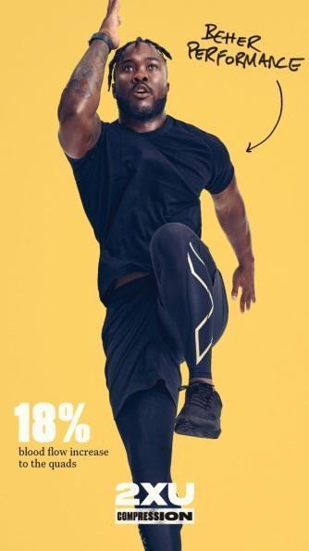
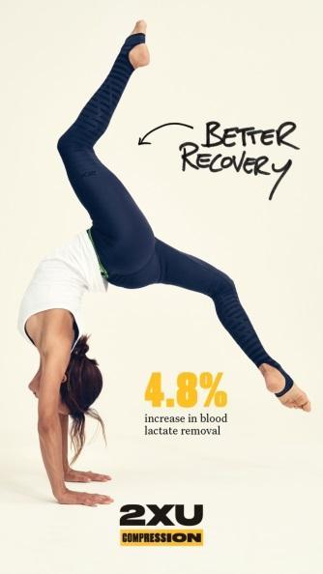
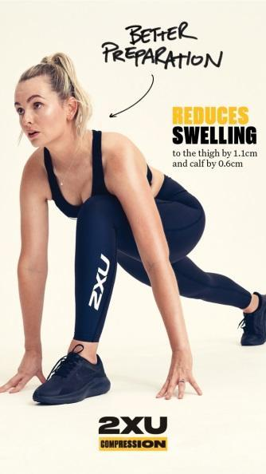

Advantages of MCS Compression

When compared to other compression products, MCS Compression has a maximum compression of 23-26*mmHg, which falls under the highest in the 2XU's compression range. Studies show that the greater the degree of compression properly applied to the body, the greater the increase in blood flow. Such increased blood flow has been found to improve performance and speed recovery.

“MCS Compression by 2XU has become one of my essential items when I exercise, especially when I compete. With maximum compression, MCS Compression helps me to give my best performance,” said Indonesia triathlon athlete, Jauhari Johan, bronze medalist at the 2021 Hanoi SEA Games.

4 Types of MCS Compression

MCS Compression has 4 different compression levels and types for different sports activities. These four types are FORM (mild compression level), CORE, AERO, MOTION & IGNITION (moderate compression level), FORCE & LIGHT SPEED (firm compression level), and RECOVERY (extra firm compression level). MCS Compression can be found in the firm compression level.




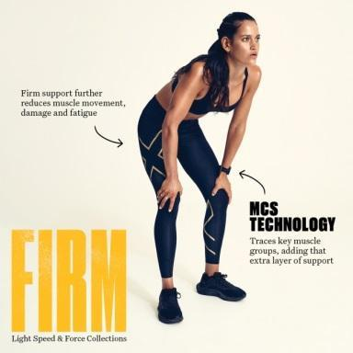

”The 4 types of MCS Compression gives the user more choices, designed to meet the needs of the user, thus supporting the performance of the user more effectively. For example, if you want to use mild compression level, you can use FORM, then if in the next exercise you want to focus more on the recovery, you can use extra firm,” said Jemima Djatmiko, CrossFit & Weightlifting coach, who just finished the World Series of Fitness Racing in Las Vegas and became the first Indonesian woman to take part.

In a series of Kota Kasablanka store’s launching, 2XU also conducted education session about the benefits of using compression to the community by collaborating with fitness centers in Jakarta such as Paradigm and Bodyfit.

***

ABOUT 2XU

Since its launch in 2005, 2XU (Two Times You) has been creating the world’s best compression to help athletes of all disciplines prepare, perform, and recover.

Backed by years of research, 2XU has partnered with a team of leading researchers to scientifically test their garments and ensure their resistance to the demands of various sports.

Their mission does not stop there. 2XU helped people to redefine their goals and focus, and to make a difference. 2XU shows everyone that change is possible, and a fitter, healthier life is possible.

The rebels, the slow-coaches, the joggers, the paddlers, the spinners - anyone who has ever thought 'I can't do that'. 2XU is showing them they can.

To know more about the full range of 2XU products, please follow our instagram @2XU_indonesia.

ABOUT PT MAP AKTIF ADIPERKASA TBK (MAPA)

At the end of December 2021, MAPA, a subsidiary of PT Mitra Adiperkasa Tbk (MAPI), operated 1,128 outlets in 78 cities across Indonesia and managed more than 40 brand exclusives. The company's three main business segments are Sports products, Leisure footwear and Kids. MAPA also operates a retail network of multi-brand exclusives, including Planet Sports Asia, Foot Locker, Sports Station, Golf House, Royal Sporting House, Kidz Station, Planet Sports Kids, and many more. In 2018, the company acquired Astec, the leader of badminton, fitness, and activity leisure brand at the regional level, which was founded by Alan Budikusuma and Susi Susanti, Olympic and World Championship gold medalists.

To obtain more detailed information about MAPA, please visit www.mapactive.id.

