Heat The Stage
Under The Spotlight

——STACCATO 2022FW PRESS RELEASE

I am woman, hear me roar! They break through bias and challenge the mainstream music awareness. The feminine image of their spontaneous and independent attitude creates a unique cultural symbol in the history of music.

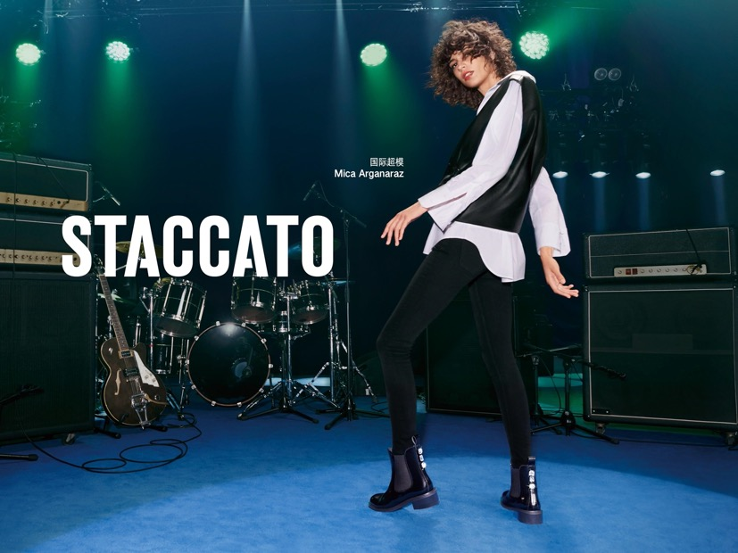
This season, STACCATO features the international supermodel Mica Arganaraz to pay homage to the female rock n’ roll pioneers and look for the synchronizing rhythm between classic and modern! With her glamorous chic and expressive talent, Mica plays with the dynamic beats to release her indulgent attitude and liberal soul on stage, revealing the cool and chic vibes in every movement. Let’s follow Mica to heat the stage under the spotlight!

Innovative Rubber

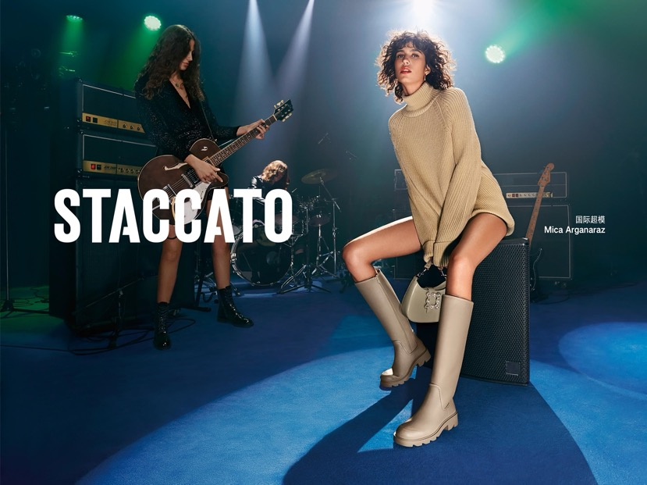
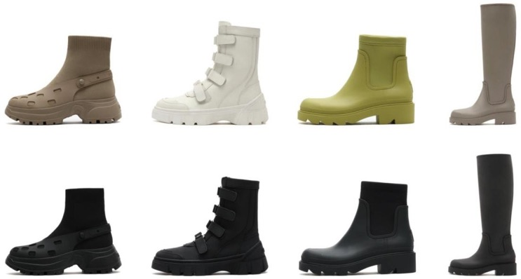
Thick rubber platform adds a spontaneous touch to these masculine boots to kick away dullness. With a cream colorway, the dynamic boots are designed with multi-strap fasteners to enhance the voluminous aesthetics. The simple yet stylish slip-on design expresses the avant-garde side and glamourous personality.

Rock n’ Roll Era

Retro style makes a return with patina leather! The chic Bordeaux red boots open up a wild and romantic charisma for a rebellious touch. The crisp silhouette highlights a courageous and confident look, and the metallic embellishments present chic elegance. Break the rule and go for a punk rock style to reinterpret the feminine power.
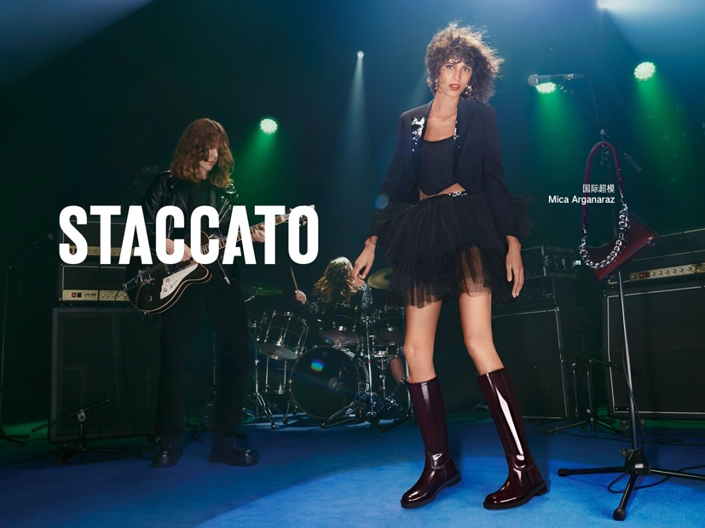
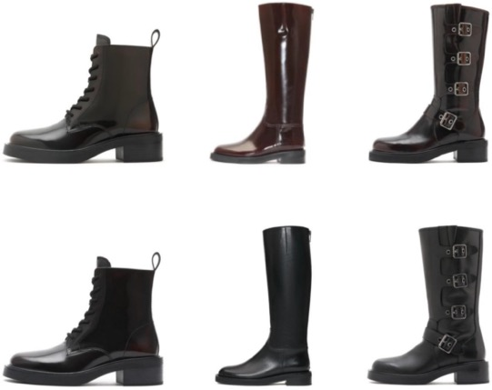

Contrasting Chic

Masculine leather represents a discreet glamour, while the flexible flyknit fabric reveals your attitude. The unique patchwork design holds against the stereotype and rebuilds a modern style, with a square strass buckle to highlight a bold and stylish attitude.
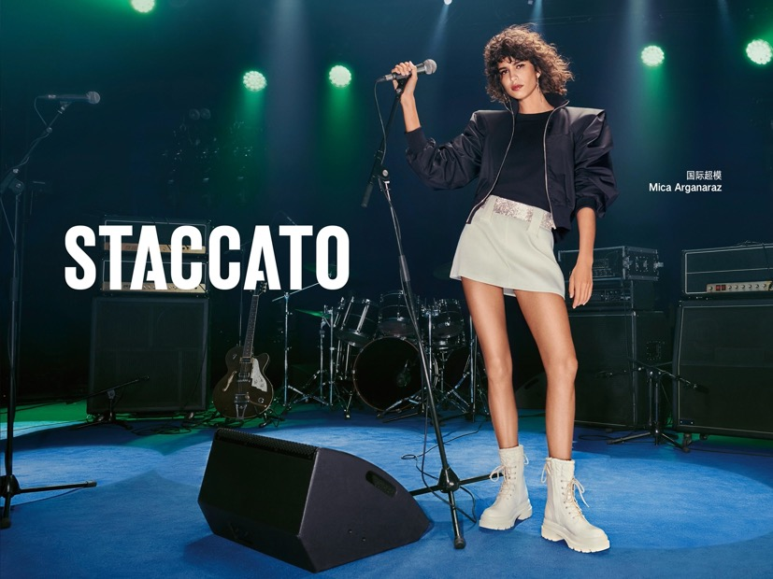

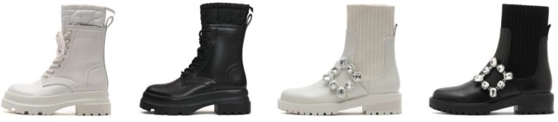

Glittering Glamour

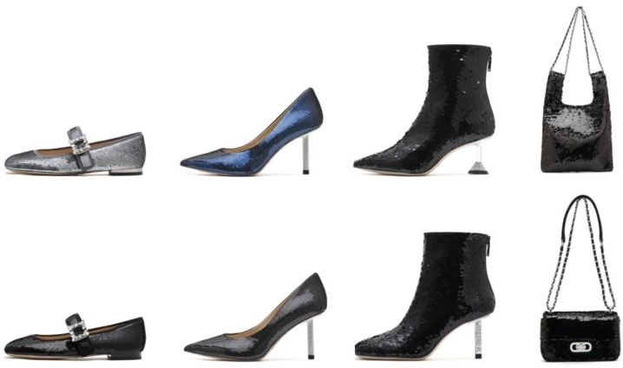
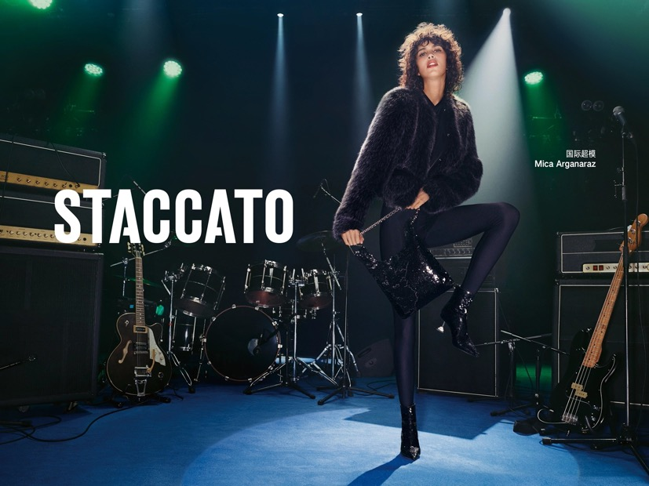
Sequin embroidery shimmers with glittering beams that shine up your heart. The glamourous diamond heels are eye-catching that instantly brighten up the starry night. The gorgeous lazurite blue and cool mysterious black and silver unveil the beauty of implicit luxury. With every stride you make, these fairy shoes expose infinite possibilities!

Monochrome Rhythm

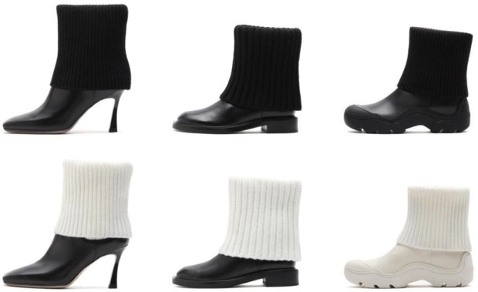
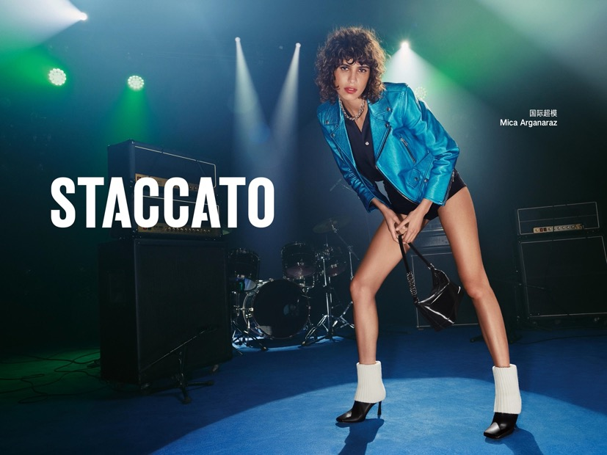
The soft and delicate knit shaft adds a bold character to the simple yet textured leather boots to interpret a perfect contrast of retro and trendy style. The coolest chic of classic monochrome palette showcases a modern touch to compose a brand new melody.

Winter Gold

Textured patina leather reveals your stylish personalities. The modern retro Chelsea boots and dandy Martin boots both express a cool outlook at ease. The meticulous metallic clasp on the shoes discreetly unveils a touch of unique style.
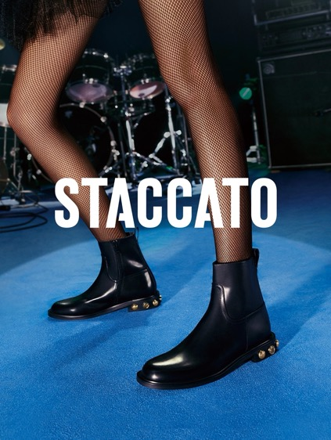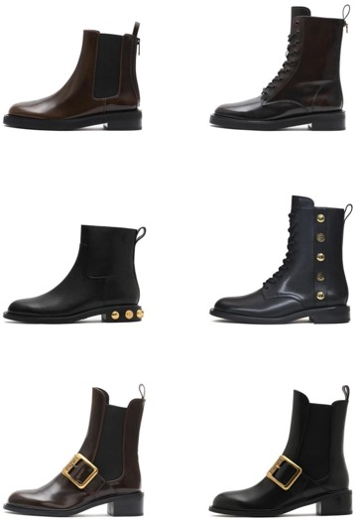

Modern Patent Leather

Eclectic patent leather features a modern chic that perfectly represents an edgy style. Adorned with a unique diamond clasp, the design is completed with a yuppie style, while the curvy line of ingenious heels adds a refined beauty along your steps.

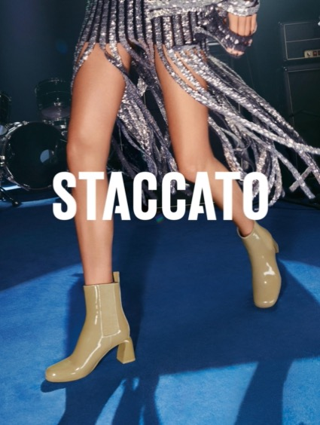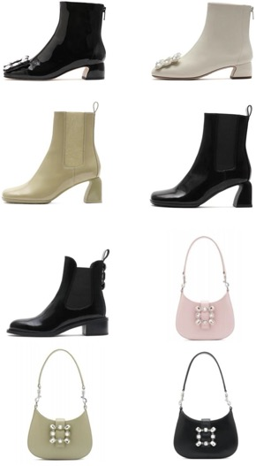

Casual Berber Fleece

The soft and cozy Berber fleece recalls a warm memory of winter. The metal chain adds a playful touch that completes the design with a sophisticated vibe. The square strass buckle reflects a shimmering shine for a contrasting aesthetics. The simple and fluid silhouette easily creates a cozy chic that releases a new outlook!
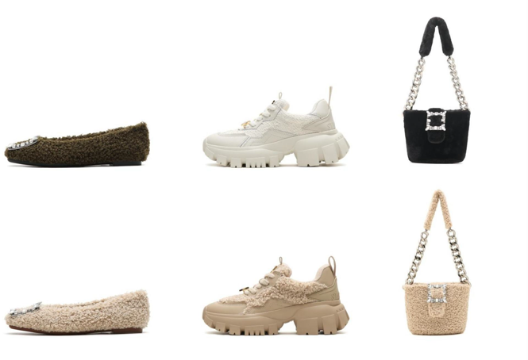

A Touch of Diamond Check

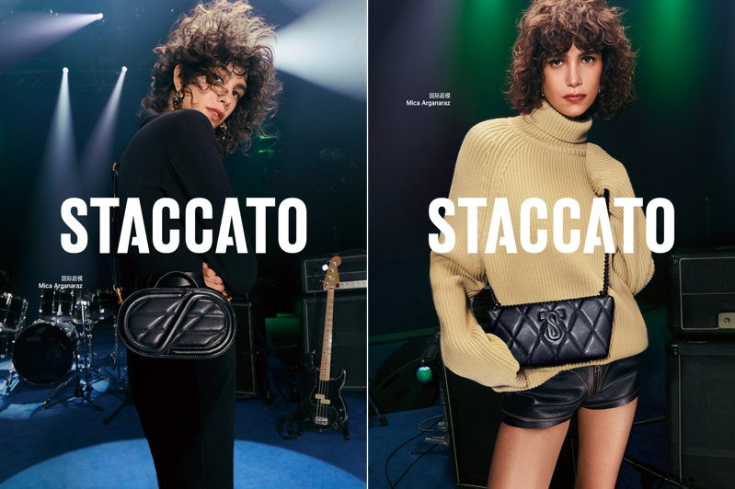
The retro diamond motif adds an intricate and playful touch to the eye-catching textured cowhide leather. The rich texture of this chic design creates a sculptural outlook with a metallic clasp to reveal the versatile charisma.

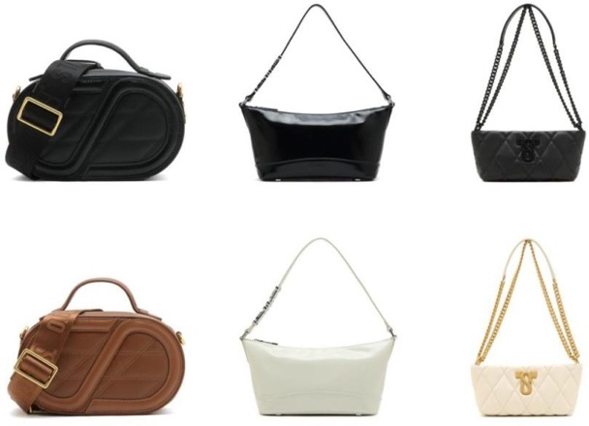

Trendy Chain

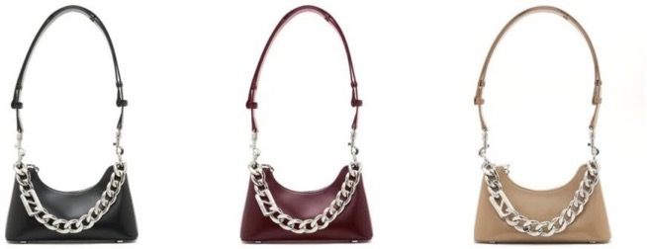
The underarm bag, a fashionable item since the last century, remains a prevailing design this season. As an eye-catching detail, the chunky chain expresses a spontaneous attitude to add a chic street style.

Unique Outlook

The rich retro monochrome check motif naturally reflects a refined elegance. Refined details including the classic metal horsebit clasp and playful toto charm feature as the eye-catching elements to ignite a dynamic vibe.
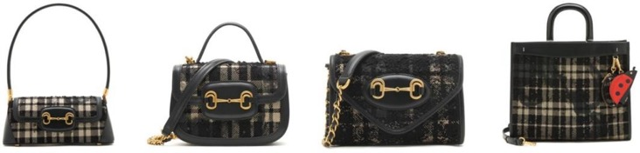

Release a dashing style and free your soul, and ignite the rhythm to heat the stage. Let’s rock under the music and make a splash with STACCATO!

